**Navigation**

В тексте задания скорее всего содержится ошибка. В самом конце предлагается определить разметку content_main.xml как RelativeLayout, но в таком случае содержимое выбранного фрагмента будет накладываться на содержимое контейнера. Смею предположить, что надо указывать LinearLayout.

Исходный код проекта:

<https://github.com/verkhoumov/AndroidLabs/tree/master/Navigation>

Скриншоты экрана:

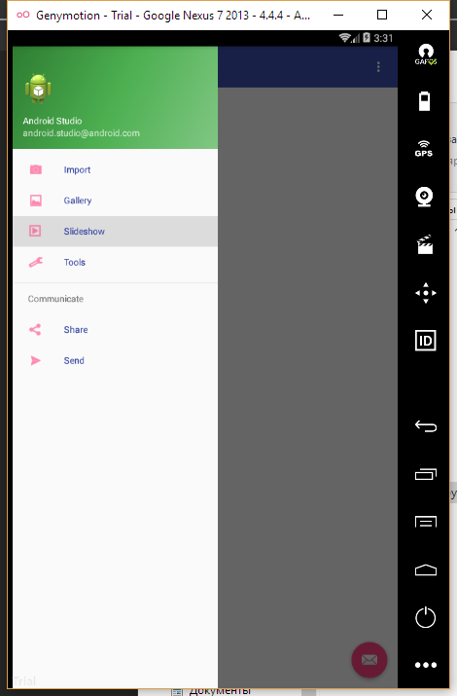

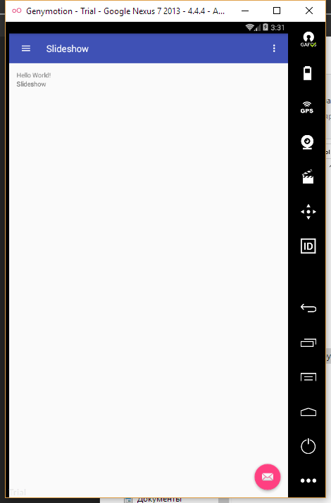

Исходный код.

MainActivity.java:

1. **package** ru.verkhoumov.navigation;
3. **import** android.os.Bundle;
4. **import** android.support.design.widget.FloatingActionButton;
5. **import** android.support.design.widget.Snackbar;
6. **import** android.support.v4.app.Fragment;
7. **import** android.support.v4.app.FragmentManager;
8. **import** android.view.View;
9. **import** android.support.design.widget.NavigationView;
10. **import** android.support.v4.view.GravityCompat;
11. **import** android.support.v4.widget.DrawerLayout;
12. **import** android.support.v7.app.ActionBarDrawerToggle;
13. **import** android.support.v7.app.AppCompatActivity;
14. **import** android.support.v7.widget.Toolbar;
15. **import** android.view.Menu;
16. **import** android.view.MenuItem;
17. **import** android.widget.Toast;
19. **public** **class** MainActivity **extends** AppCompatActivity
20. **implements** NavigationView.OnNavigationItemSelectedListener {
22. @Override
23. **protected** **void** onCreate(Bundle savedInstanceState) {
24. **super**.onCreate(savedInstanceState);
25. setContentView(R.layout.activity_main);
26. Toolbar toolbar = (Toolbar) findViewById(R.id.toolbar);
27. setSupportActionBar(toolbar);
29. FloatingActionButton fab = (FloatingActionButton) findViewById(R.id.fab);
30. fab.setOnClickListener(**new** View.OnClickListener() {
31. @Override
32. **public** **void** onClick(View view) {
33. Snackbar.make(view, "Replace with your own action", Snackbar.LENGTH_LONG)
34. .setAction("Action", **null**).show();
35. }
36. });
38. DrawerLayout drawer = (DrawerLayout) findViewById(R.id.drawer_layout);
39. ActionBarDrawerToggle toggle = **new** ActionBarDrawerToggle(
40. **this**, drawer, toolbar, R.string.navigation_drawer_open, R.string.navigation_drawer_close);
41. drawer.addDrawerListener(toggle);
42. toggle.syncState();
44. NavigationView navigationView = (NavigationView) findViewById(R.id.nav_view);
45. navigationView.setNavigationItemSelectedListener(**this**);
46. }
48. @Override
49. **public** **void** onBackPressed() {
50. DrawerLayout drawer = (DrawerLayout) findViewById(R.id.drawer_layout);
51. **if** (drawer.isDrawerOpen(GravityCompat.START)) {
52. drawer.closeDrawer(GravityCompat.START);
53. } **else** {
54. **super**.onBackPressed();
55. }
56. }
58. @Override
59. **public** **boolean** onCreateOptionsMenu(Menu menu) {
60. *// Inflate the menu; this adds items to the action bar if it is present.*
61. getMenuInflater().inflate(R.menu.main, menu);
62. **return** **true**;
63. }
65. @Override
66. **public** **boolean** onOptionsItemSelected(MenuItem item) {
67. *// Handle action bar item clicks here. The action bar will*
68. *// automatically handle clicks on the Home/Up button, so long*
69. *// as you specify a parent activity in AndroidManifest.xml.*
70. **int** id = item.getItemId();
72. *//noinspection SimplifiableIfStatement*
73. **if** (id == R.id.action_settings) {
74. **return** **true**;
75. }
77. **return** **super**.onOptionsItemSelected(item);
78. }
80. @SuppressWarnings("StatementWithEmptyBody")
81. @Override
82. **public** **boolean** onNavigationItemSelected(MenuItem item) {
83. *// Создание нового фрагмента.*
84. Fragment fragment = **null**;
85. **Class** fragmentClass = **null**;
87. *// Handle navigation view item clicks here.*
88. **int** id = item.getItemId();
90. **if** (id == R.id.nav_camera) {
91. fragmentClass = ImportFragment.**class**;
92. } **else** **if** (id == R.id.nav_gallery) {
93. fragmentClass = GalleryFragment.**class**;
94. } **else** **if** (id == R.id.nav_slideshow) {
95. fragmentClass = SlideshowFragment.**class**;
96. } **else** **if** (id == R.id.nav_manage) {
97. fragmentClass = ToolsFragment.**class**;
98. } **else** **if** (id == R.id.nav_share) {
99. fragmentClass = ShareFragment.**class**;
100. } **else** **if** (id == R.id.nav_send) {
101. fragmentClass = SendFragment.**class**;
102. }
104. **try** {
105. fragment = (Fragment) fragmentClass.newInstance();
106. } **catch** (Exception e) {
107. e.printStackTrace();
108. }
110. *// Вставка фрагмента с заменой текущего.*
111. FragmentManager fragmentManager = getSupportFragmentManager();
112. fragmentManager.beginTransaction().replace(R.id.container, fragment).commit();
113. *// Активация выбранного пункта меню.*
114. item.setChecked(**true**);
115. *// Выводим заголовок выбранного пункта.*
116. setTitle(item.getTitle());
118. DrawerLayout drawer = (DrawerLayout) findViewById(R.id.drawer_layout);
119. drawer.closeDrawer(GravityCompat.START);
120. **return** **true**;
121. }
122. }

ImportFragment.java, GalleryFragment.java, SlideshowFragment.java, ToolsFragment.java, ShareFragment.java и SendFragment.java (аналоги):

1. **package** ru.verkhoumov.navigation;

4. **import** android.os.Bundle;
5. **import** android.support.v4.app.Fragment;
6. **import** android.view.LayoutInflater;
7. **import** android.view.View;
8. **import** android.view.ViewGroup;

11. **public** **class** ImportFragment **extends** Fragment {
12. @Override
13. **public** View onCreateView(LayoutInflater inflater, ViewGroup container, Bundle savedInstanceState) {
14. **return** inflater.inflate(R.layout.fragment_import, container, **false**);
15. }
16. }

fragment_import.xml, fragment_gallery.xml, fragment_slideshow.xml, fragment_tools.xml, fragment_share.xml и fragment_send.xml (аналоги):

1. **<FrameLayout** xmlns:android="http://schemas.android.com/apk/res/android"
2. xmlns:tools="http://schemas.android.com/tools"
3. android:layout_width="match_parent"
4. android:layout_height="match_parent"
5. tools:context="ru.verkhoumov.navigation.ImportFragment"**>**
7. **<TextView**
8. android:layout_width="match_parent"
9. android:layout_height="match_parent"
10. android:text="@string/fragment_import" **/>**
11. **</FrameLayout>**

activity_main.xml:

1. **<?xml** version="1.0" encoding="utf-8"**?>**
2. **<android.support.v4.widget.DrawerLayout** xmlns:android="http://schemas.android.com/apk/res/android"
3. xmlns:app="http://schemas.android.com/apk/res-auto"
4. xmlns:tools="http://schemas.android.com/tools"
5. android:id="@+id/drawer_layout"
6. android:layout_width="match_parent"
7. android:layout_height="match_parent"
8. android:fitsSystemWindows="true"
9. tools:openDrawer="start"**>**
11. **<include**
12. layout="@layout/app_bar_main"
13. android:layout_width="match_parent"
14. android:layout_height="match_parent" **/>**
16. **<android.support.design.widget.NavigationView**
17. android:id="@+id/nav_view"
18. android:layout_width="wrap_content"
19. android:layout_height="match_parent"
20. android:layout_gravity="start"
21. android:fitsSystemWindows="true"
22. app:headerLayout="@layout/nav_header_main"
23. app:menu="@menu/activity_main_drawer"
24. app:itemIconTint="@color/colorAccent"
25. app:itemTextColor="@color/colorPrimaryDark" **/>**
27. **</android.support.v4.widget.DrawerLayout>**

content_main.xml:

1. **<?xml** version="1.0" encoding="utf-8"**?>**
2. **<LinearLayout** xmlns:android="http://schemas.android.com/apk/res/android"
3. xmlns:app="http://schemas.android.com/apk/res-auto"
4. xmlns:tools="http://schemas.android.com/tools"
5. android:id="@+id/container"
6. android:layout_width="match_parent"
7. android:layout_height="match_parent"
8. android:paddingBottom="@dimen/activity_vertical_margin"
9. android:paddingLeft="@dimen/activity_horizontal_margin"
10. android:paddingRight="@dimen/activity_horizontal_margin"
11. android:paddingTop="@dimen/activity_vertical_margin"
12. android:orientation="vertical"
13. app:layout_behavior="@string/appbar_scrolling_view_behavior"
14. tools:context="ru.verkhoumov.navigation.MainActivity"
15. tools:showIn="@layout/app_bar_main"**>**
17. **<TextView**
18. android:layout_width="wrap_content"
19. android:layout_height="wrap_content"
20. android:text="Hello World!" **/>**
21. **</LinearLayout>**